🟢 Bandit Level 12 → Level 13
This level is about extracting a repeatedly compressed file.
Here is the step-by-step breakdown of the OverTheWire Bandit Level 12 → Level 13 walkthrough shown in your screenshot:
1. Create a Temporary Working Directory Since you don't have write permissions in your home directory, navigate to /tmp and create a dedicated workspace
Setup & Reverse Hex Dump:
Bash
cd /tmp
mkdir bandit12
cd bandit12
cp ~/data.txt .
xxd -r data.txt data.bin
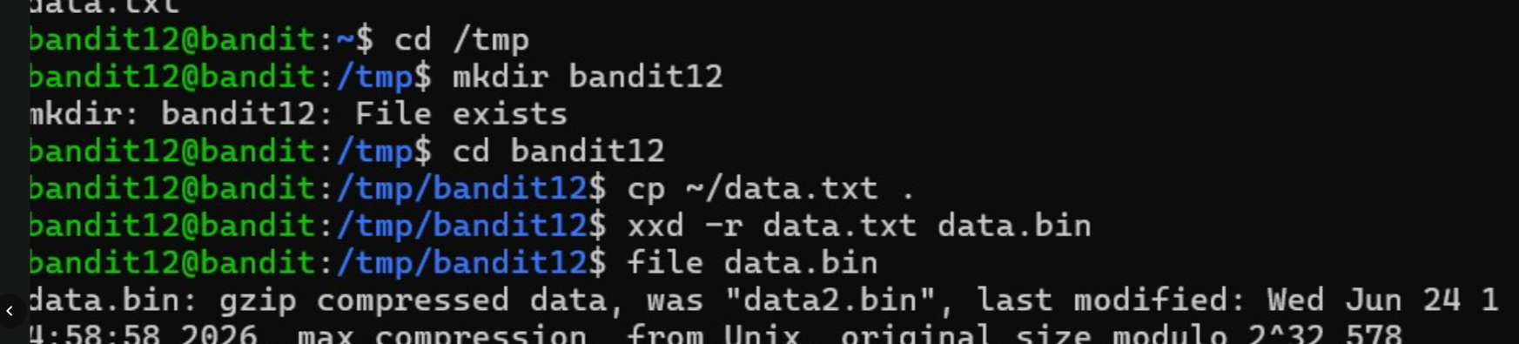
2.First Decompression (Gzip):
Bash
mv data.bin data.gz
gzip -d data.gz
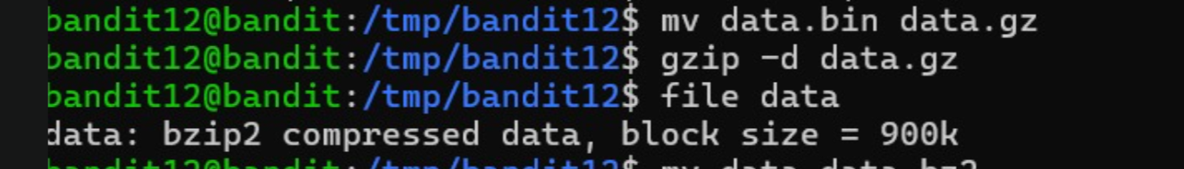
3.Second Decompression (Bzip2):
Bash
mv data data.bz2
bzip2 -d data.bz2
4.Third Decompression (Tar Archive):
Bash
mv data data.tar
tar -xf data.tar
Identify Extracted Files & Retrieve Password: Checking file types reveals that data9.bin contains the uncompressed ASCII text:
Bash
file data*.bin
cat data9.bin
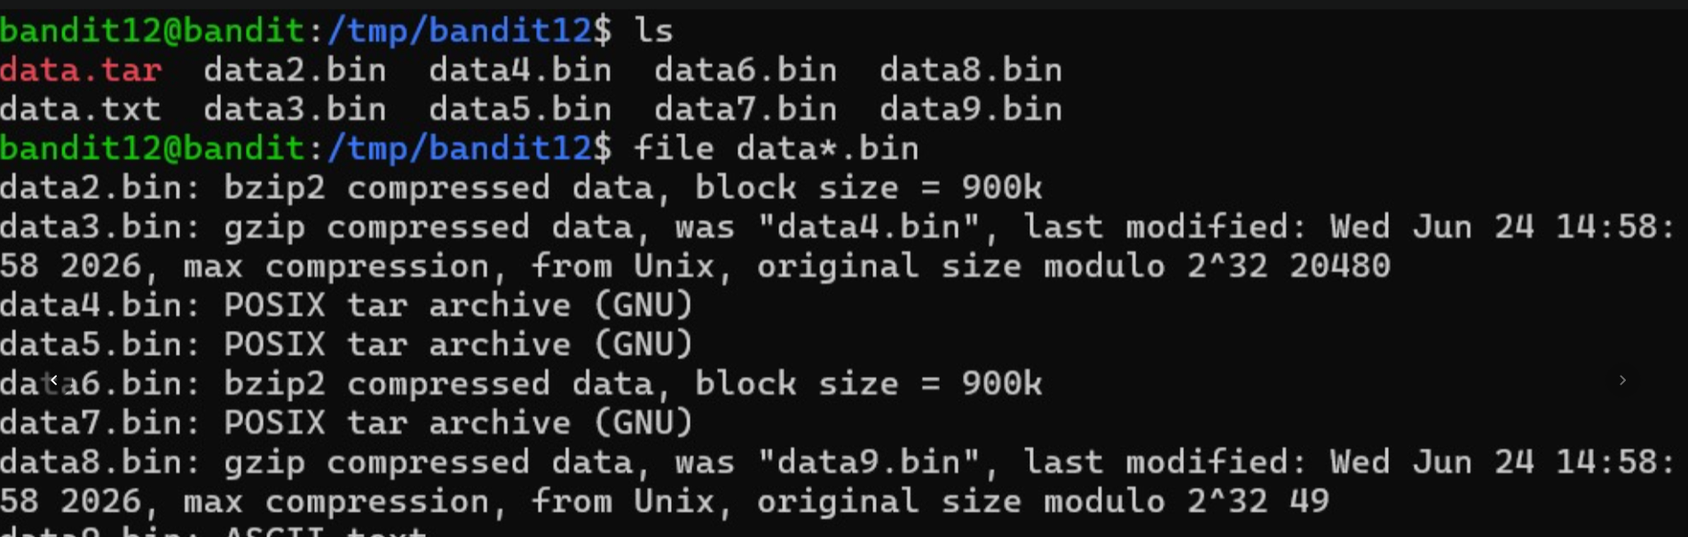
Password Found: qQYQiHOBPR8zR61qxYqX45quvihF2uzk
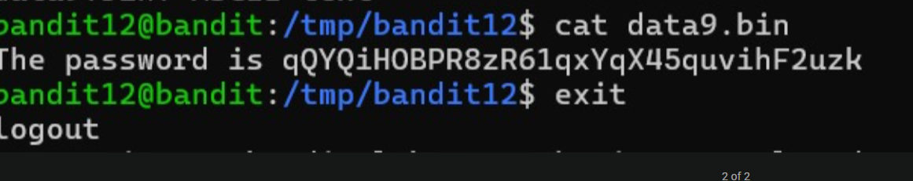
Then exit from that file

